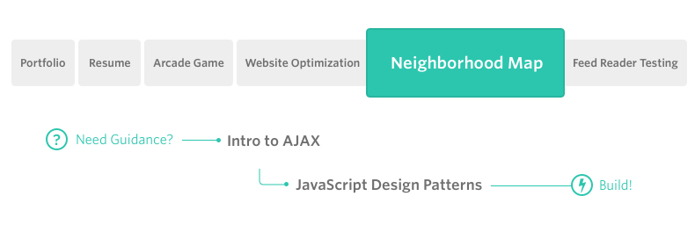

**Project Overview**

You will develop a single page application featuring a map of your neighborhood or a neighborhood you would like to visit. You will then add additional functionality to this map including highlighted locations, third-party data about those locations and various ways to browse the content.

**Why this Project?**

The neighborhood tour application is complex enough and incorporates a variety of data points that it can easily become unwieldy to manage. There are a number of frameworks, libraries and APIs available to make this process more manageable and many employers are looking for specific skills in using these packages.

**What will I Learn?**

You will learn how design patterns assist in developing a manageable codebase. You’ll then explore how frameworks can decrease the time required developing an application and provide a number of utilities for you to use. Finally, you’ll implement third-party APIs that provide valuable data sets that can improve the quality of your application.

**How does this help my Career?**

* Interacting with API servers is the primary function of Front-End Web Developers
* Use of third-party libraries and APIs is a standard and acceptable practice that is encouraged